

CV

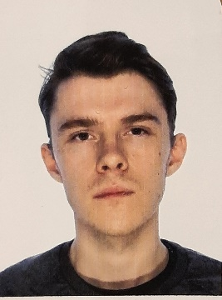

# Anton Borisov, 20 years old

Date: 17.01.2002

https://thesameanton.github.io/Portfolio/#en

# +420605398019

# C:\Users\Rijo\AppData\Local\Microsoft\Windows\INetCacheContent.Word\Layer 5.png [ant.b.a.2002.17@gmail.com](mailto:ant.b.a.2002.17@gmail.com)

# Address: Prague 7 Holešovice

# Property

# 

# I am a newly admitted student at ČZU the University in the Informatics program.

# In addition to studying at university, I like to learn something new outside of it. I read some different books on programming (most recently "Grokking Algorithms" and some publications "Headfirst").

# I am a reliable and purposeful student who wants to improve his skills. I can approach work responsibly and work in a team. I have analytical and systematic thinking, I like to plan and I usually spend a lot of time on it. What I can say for sure is that I’m not afraid of making mistakes. Standing still and not developing is much worse. That is why I’m always looking for new and reliable, up-to-date information! In addition to writing codes on a regular basis, I also attend certain events and meetups, courses, and lectures related to development and design, which one can find freely available on the Internet. An interesting fact about me is that I am self-taught. But I don’t think it will cause trouble. On the contrary, I think that this approach has many advantages. Firstly, it is independence, which I have developed over the years. Secondly, if there’s a problem, I don’t need to ask for help from a mentor. I managed to master an important skill for my profession – «the ability to google»

# Education

# HIGH SCHOOL

# 2008 - 2019

# 

**HIGHER EDUCATION**

**2020 – now**

**Czech University of Life Sciences Prague (CZU)**

# Study program: Informatics

# Skills

# HTML5

# CSS3 (SASS, LESS, Bootstrap, Responsive + Adaptive, Methodology BEM)

# JavaScript (ES6)

# GitHub, GIT (init, commit, push, create PR)

# SVG

# Gulp, Webpack

# Photoshop, Figma, Avocode

# MS Office (Word, MS Excel, etc.)

# English (B1 – B2)

# Czech (B2)

# Russian (native speaker)